**Software Engineering Lab (15B17CI573) – ODD 2022**

**Lab Test 2**

**Max Time:** 1 hour **Max Marks:**20

**Instructions:**

1. Submission of all the questions will be in a single word file.

2. Filename should be ***Batch_RollNo_Name_LT1_SE.docx***

**Case Study**

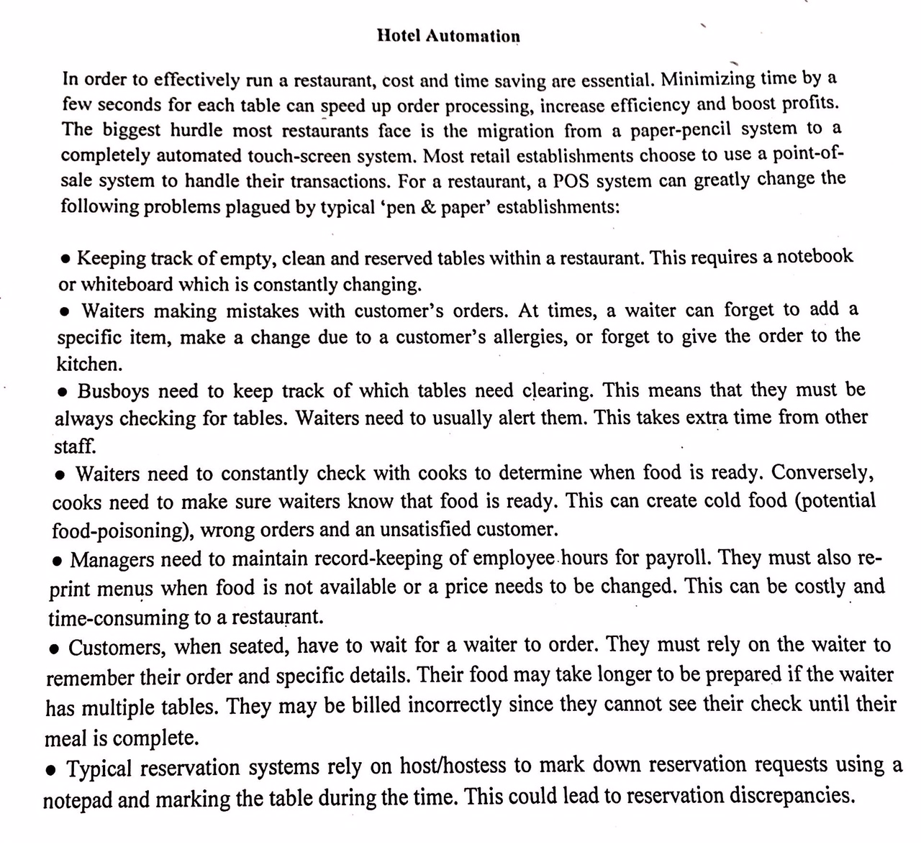 **[C374.2] Q1.** Draw the Activity Diagram for the above system. **[10 Marks]**

**[C374.3] Q2.** Refractor the following code fragment. [**5 Marks]**

if(A && B && (C || D)){printf(“Hi”)}

else{printf(“%d”,(C || D));}

if(A && !B && (C || D)){}

else{printf(“%d”,(C || D));}

if(!A && B && (C || D)){}

else{printf(“%d”,(C || D));}

**[C374.4] Q3.** Generate test cases using boundary value analysis. [**5 Marks]**

An employee has $4000 of salary tax free. The next $1500 is taxed at 10%. The   next $28000 is taxed at 22%. Any further amount is taxed at 40%.